**ABOUT THE 50 STARTUPS DATASET**

**ASSIGNMENT -1**

**SNEKHA A**

**113219041112**

BASED ON MARKETING AND PROFIT BY STATE

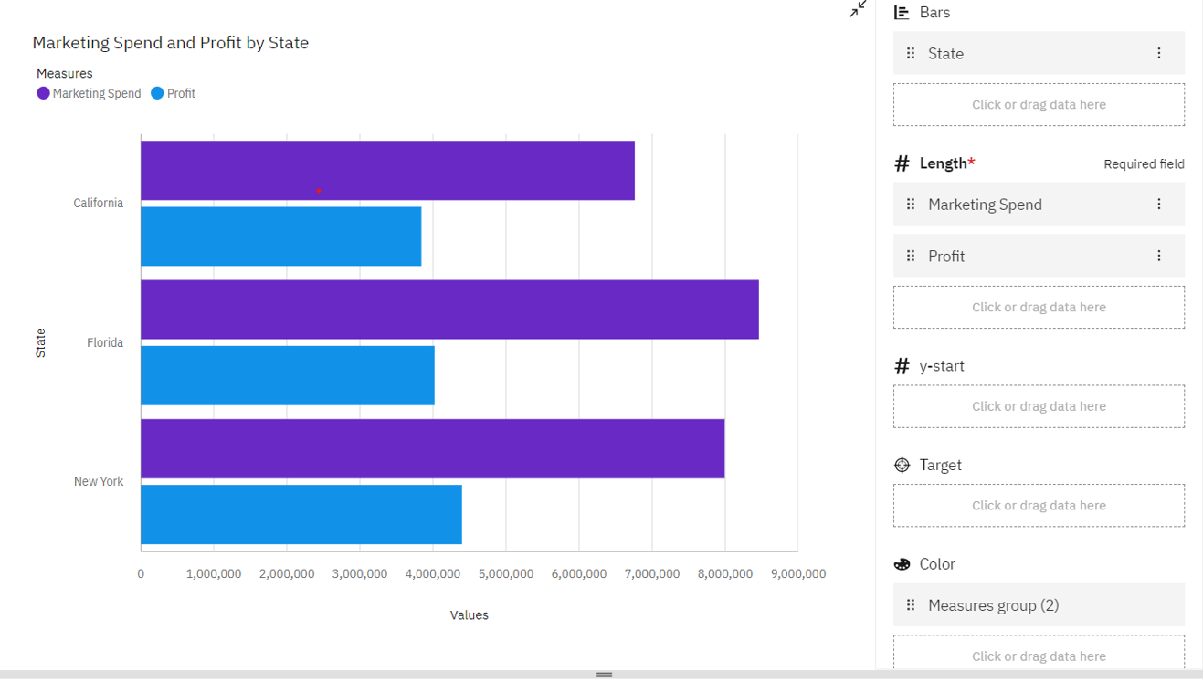

BASED ON ADMINISTRATION AND PROFIT BY STATE

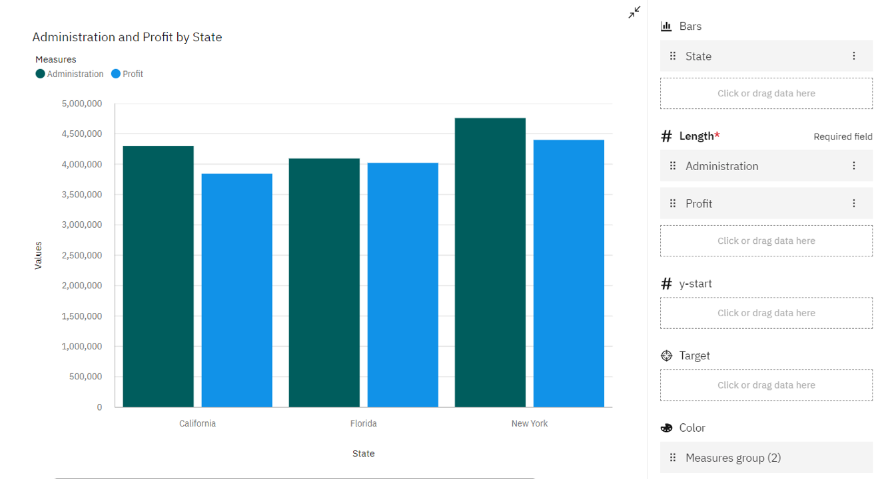

BASED ON PROFIT AND MARKETING SPEND BY STATE

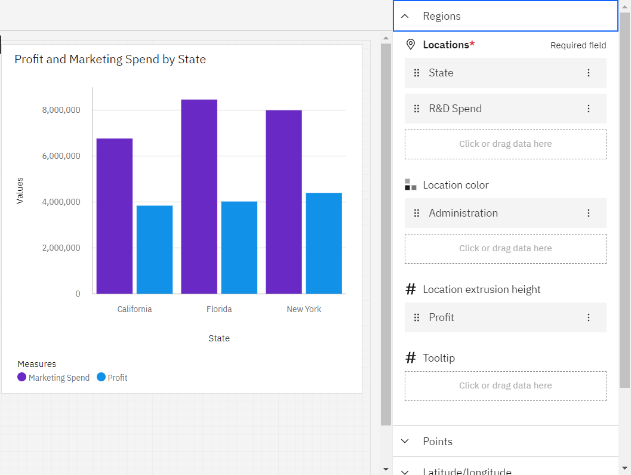

BASED ON ADMINISTRATION,MARKETING,SPEND,STATE

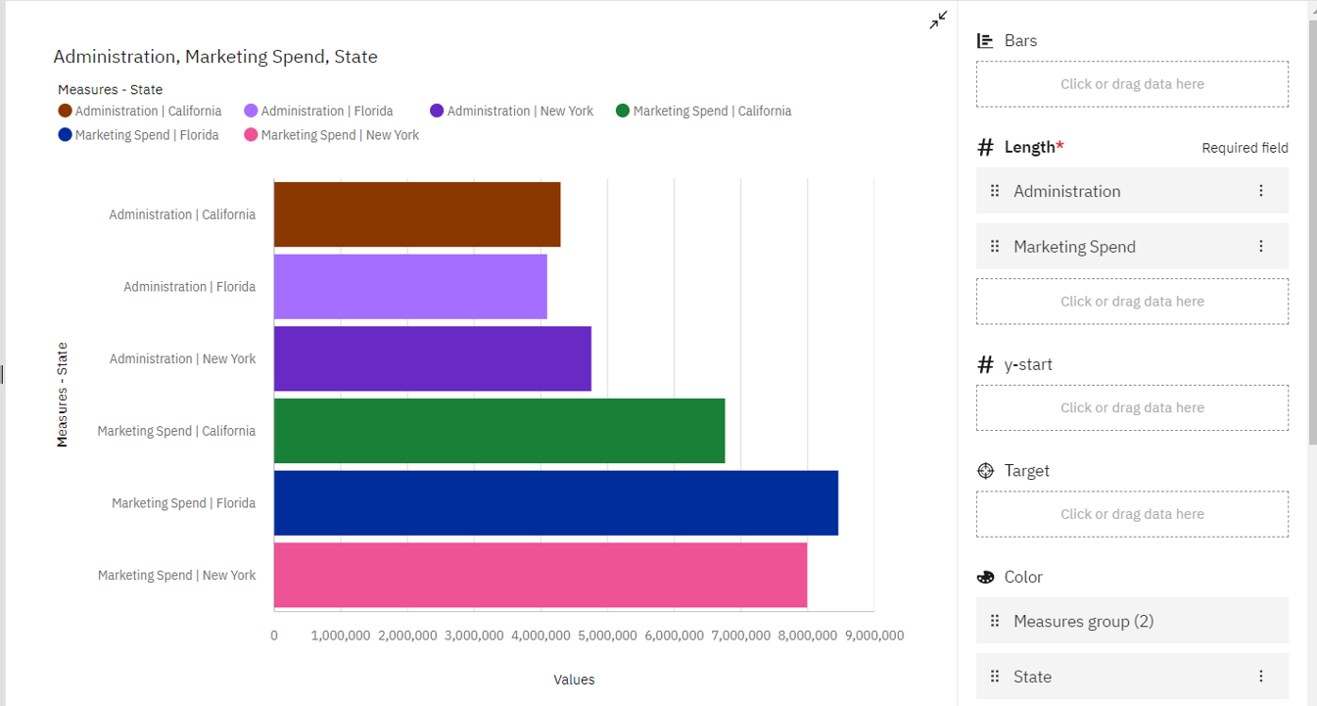

BASED ON ADMINISTRATION AND STATE WITH ADMINISTRATION AND PROFIT FOR STATE

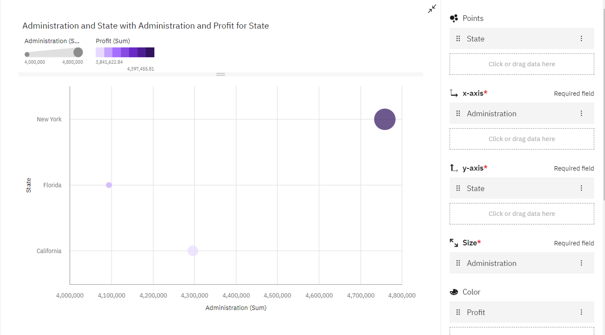

BASED ON ADMINISTRATION,MARKETING,SPEND,PROFIT

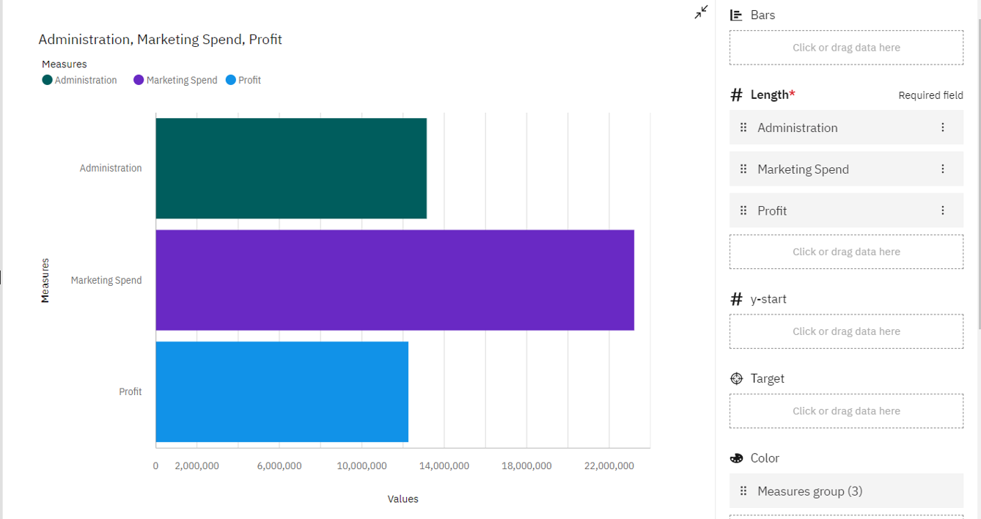

BASED ON R & D SPEND AND MARKETING SPEND BY STATE

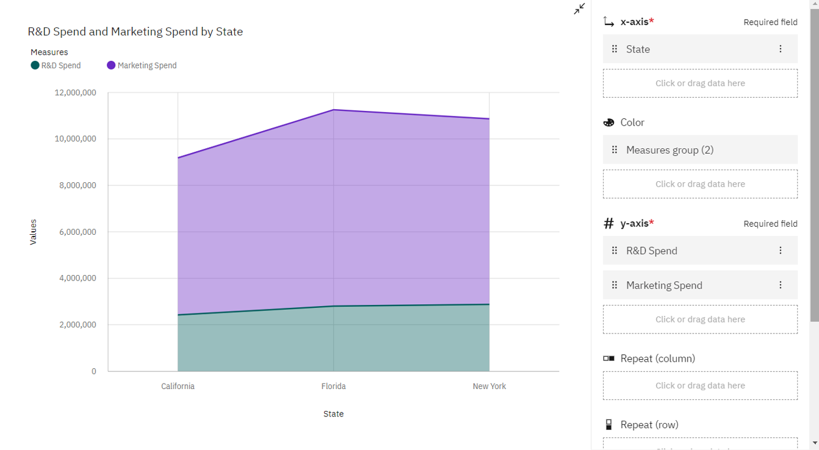

BASED ON STATE HIERARCHY COLORED BY ADMINISTRATION AND SIZED BY PROFIT

